Geopolitical Risk and U.S. Stock Market Volatility: Evidence from the U.S.–China Tension Index

Appendix A: Background
In recent years, the escalating tensions between the U.S. and China have become a prominent feature of the global geopolitical landscape. Encompassing trade conflicts (Bianconi et al., 2021; Yilmazkuday, 2025), technological competition (Zhang, 2024), and military posturing (Glaser, 2015), these factors collectively constitute a systemic and long-term source of geopolitical risk, bringing sustained uncertainty to global financial and economic markets.
In the economic and trade sphere, the rise in trade policy uncertainty has significantly increased the risk premium of major U.S. stock indices, with an annualized increase of 4% to 6% (Bianconi et al., 2021). Building on this, some studies suggest that when the U.S. imposes additional tariffs or trade policy expectations deteriorate, major indices such as the S&P 500, Dow Jones, and Nasdaq may cumulatively decline by 7% to 10% over the next two years (Yilmazkuday, 2025). Such shocks not only trigger significant fluctuations in asset prices but also have profound implications for cross-border capital flows, global asset allocation, and corporate profit expectations.
At the technological level, U.S. restrictions on technology transfers to China reflect geopolitical competition over global technological dominance. Technological advantages are not only crucial to national security but also significantly determine a country's influence and institutional shaping capabilities in global governance (Zhang, 2024).
On the security front, faced with China's rapid rise, the U.S. is grappling with a difficult choice between “military competition” and “strategic dialogue,” particularly given its long-standing security commitments toward Taiwan, which could serve as a potential trigger for strategic conflict between the U.S. and China, and exacerbate geopolitical competition over maritime transport routes in East Asia (Glaser, 2015).
The aforementioned geopolitical risks are being transmitted to global markets through financial channels. On the one hand, the escalation of U.S.-China tensions often triggers risk aversion (such as a decline in investor risk appetite and capital inflows into safe assets), driving up the prices of safe-haven assets such as gold, while also causing sharp adjustments in stock markets and a significant increase in volatility (Chiang, 2022; Feder-Sempach et al., 2024; Triki & Ben Maatoug, 2021). On the other hand, exchange rate markets are also significantly affected by changes in policy expectations, which may lead to structural fluctuations, thereby exacerbating the contagion effect on global asset prices and systemic risks in financial markets (Lu et al., 2024; Wang & Lee, 2022).
Therefore, the evolution of U.S.-China relations not only constitutes a core issue in bilateral relations but also represents an important external shock source affecting global economic and financial stability. Systematically assessing and deeply understanding the impact of U.S.-China tensions on financial markets is of great theoretical value and practical significance.

Appendix B: Literature Review
The impact of geopolitical risk (GPR) on stock market volatility has garnered significant scholarly attention. Existing literature approaches this issue from three primary perspectives: macro-finance theory, behavioral finance, and global risk transmission mechanisms.
From the macro-financial perspective, uncertainty shocks are regarded as a fundamental determinant of asset pricing and market volatility. Caldara and Iacoviello (2022) pioneered the construction of a geopolitical risk index (GPR) within a vector autoregression (VAR) framework. Their empirical findings indicate that increases in GPR significantly elevate the VIX index and depress equity prices, thus exhibiting the characteristics of a prototypical “uncertainty shock effect”. This study suggests that rising geopolitical risk increases perceived market risk, leading investors to revise downward their expectations of future earnings and apply higher discount rates, thereby amplifying market fluctuations. Zhang et al. (2023) further demonstrate that the effect of GPR on volatility is more pronounced in emerging markets and during periods of peace, implying that geopolitical risk, by intensifying macroeconomic uncertainty and risk premiums, enhances the sensitivity of stock markets to external shocks.
Behavioral finance theory emphasizes that investors are not fully rational and are often influenced by emotional and cognitive biases when interpreting geopolitical information. Zaremba et al. (2022) document a counterintuitive phenomenon in which stock returns in certain emerging markets increase following a rise in geopolitical risk. This anomaly is explained through the “availability heuristic”, whereby investors overreact to highly salient geopolitical events, resulting in short-term pricing distortions. He (2023) further provides empirical evidence of a negative causal relationship between GPR and investor sentiment, indicating that geopolitical fear reinforces investors’ loss aversion, which in turn triggers abrupt changes in trading behavior and asymmetric adjustments in market volatility. These findings are consistent with key concepts in behavioral finance, such as “loss aversion” and “herding behavior”.
From a global perspective, geopolitical risk is not confined to individual markets. However, it is transmitted internationally through cross-border capital flows, shifts in asset pricing expectations, and the reallocation of safe-haven assets. Zheng et al. (2023) demonstrate that GPR is closely linked to commodity markets, particularly oil and gold, and facilitates cross-asset risk spillovers through the bond and foreign exchange markets. During geopolitical crises, assets such as gold and government bonds tend to function as safe havens, while equity markets become the primary recipients of risk transmission. Hao et al. (2024) find that GPR exerts significant and directional volatility spillovers between the equity markets of China and the U.S., with these effects becoming stronger and more persistent during periods of heightened geopolitical tension.
Furthermore, Salachas et al. (2024) use cross-country panel data to empirically investigate the transmission of geopolitical conflict to market volatility in G7 and BRICS economies. Their results reveal that GPR not only suppresses market returns but also intensifies comovements in volatility across countries. These findings are consistent with Bouras et al. (2019), who argue that global geopolitical tensions exhibit greater contagion effects on emerging markets, whereas domestic geopolitical risk plays a comparatively marginal role.

Appendix C: Methodology
This study's methodological foundation is based on Engle et al. (2013)'s pioneering work, which introduced the GARCH-MIDAS model to decompose time series data into high-frequency and low-frequency components.
The primary reasons for adopting this model are as follows:
First, the GJR-GARCH structure demonstrates excellent performance in capturing the amplifying effect of negative shocks on volatility, making it suitable for identifying asymmetric market responses to geopolitical risks.
Second, the MIDAS specification effectively utilizes the long-term trend characteristics of low-frequency variables such as geopolitical factors while preserving high-frequency financial information, aligning well with the frequency heterogeneity of the data used in this study.
Third, the model exhibits good scalability and can be further enhanced to incorporate the positive and negative decomposition of geopolitical risks, thereby revealing the heterogeneous impact of different directional shocks on long-term volatility.
Therefore, the GJR-GARCH-MIDAS model demonstrates significant advantages in terms of theoretical suitability and empirical feasibility, providing a solid methodological foundation for exploring the predictive relationship between US-China geopolitical risks and stock market volatility.
Based on the GARCH-MIDAS framework, the daily return equation is set as follows:
$$\begin{aligned}r_{i,t}=μ+\sqrt{τ_{t}*g_{i,t}}ε_{i,t} ∀i=1,…,N_{t}\#\left(1\right)\end{aligned}$$
In Equation (1), $μ$ represents the unconditional mean, t denotes time measured monthly, and $r_{i,t}$ refers to the daily log return of the market index. This equation decomposes the conditional variance into the short-term volatility component $g_{i,t}$ and the long-term volatility component $τ_{t}$.
$$\begin{aligned}g_{i,t}=\left(1-α-\frac{γ}{2}-β\right)+\left(α+γ*I_{\left\{ε_{i-1,t}<0\right\}}\right)\frac{ε_{i-1,t}^{2}}{τ_{t}}+βg_{i-1,t}\#\left(2\right)\end{aligned}$$
In Equation (2), the short-term volatility $g_{i,t}$ is modeled using the GJR-GARCH(1,1) model, as proposed by Conrad and Kleen (2020). The equation must satisfy the following conditions: $α>0$, $β≥0$, and $α+β+\frac{γ}{2}<1$. 𝛾 represents the presence of asymmetry effects.
$$\begin{aligned}lnτ_{t}=m+θ_{RV}\sum_{k=1}^{K}{φ_{k}\left(w_{1},w_{2}\right){RV}_{t-k}}\#\left(3\right)\end{aligned}$$
In Equation (3), we use the realized volatility to describe the long-term volatility and take the logarithm to ensure that $τ_{t}$ remains positive. Here, we focus primarily on the long-term impact coefficient $θ$.
$$\begin{aligned}φ_{k}\left(w_{1},w_{2}\right)=\frac{{\left(\frac{k}{K}\right)}^{w_{1}-1}{\left(1-\frac{k}{K}\right)}^{w_{2}-1}}{\sum_{j=1}^{K}{{\left(\frac{j}{K}\right)}^{w_{1}-1}{\left(1-\frac{j}{K}\right)}^{w_{2}-1}}}\#\left(4\right)\end{aligned}$$
In Equation (4), the Beta weight function reflects the decay effect of low-frequency variables on high-frequency volatility. Similarly, we set $w_{1}=1$ to ensure that the impact of each exogenous variable on long-term volatility decreases monotonically. For convenience, we refer to Equations (1), (2), (3), and (4) as Model 1.
Otherwise, Equation (3) can be extended into a multifactor model.
$$\begin{aligned}lnτ_{t}=m+θ_{RV}\sum_{k=1}^{K}{φ_{k}\left(w_{1,RV},w_{2,RV}\right){RV}_{t-k}}+θ_{UCT}\sum_{k=1}^{K}{φ_{k}\left(w_{1,UCT},w_{2,UCT}\right){UCT}_{t-k}}\#\left(5\right)\end{aligned}$$
Equation (5) considers the dynamic impact of UCT on long-term volatility, after controlling for the effect of realized volatility. Therefore, Equations (1), (2), (5), and (4) together form a new multifactor model, referred to as Model 2.
Finally, following the study by Li et al. (2025), we decompose the impact of UCT on long-term volatility in Equation (5) into positive shocks (${UCT}_{t-k}^{+}=\sum_{j=1}^{N^{'}}{UCT_{t-k}I_{\left\{UCT_{t-k}>0\right\}}}$) and negative shocks (${UCT}_{t-k}^{-}=\sum_{j=1}^{N^{'}}{UCT_{t-k}I_{\left\{UCT_{t-k}<0\right\}}}$).
$$\begin{aligned}lnτ_{t}=m+θ_{RV}\sum_{k=1}^{K}{φ_{k}\left(w_{1,RV},w_{2,RV}\right){RV}_{t-k}}+θ_{UCT}^{+}\sum_{k=1}^{K}{φ_{k}\left(w_{1,UCT}^{+},w_{2,UCT}^{+}\right){UCT}_{t-k}^{+}} \\ +θ_{UCT}^{-}\sum_{k=1}^{K}{φ_{k}\left(w_{1,UCT}^{-},w_{2,UCT}^{-}\right){UCT}_{t-k}^{-}}\#\left(6\right)\end{aligned}$$
Therefore, Equations (1), (2), (6), and (4) together constitute a new double-asymmetric multifactor model, Model 3.

Appendix D: Data Sources
The daily price data for the S&P 500 Index (SPX) and the Nasdaq Composite Index (IXIC) are sourced from the Investing.com data platform. The time-series dynamics of these indices are illustrated in Figure 1.
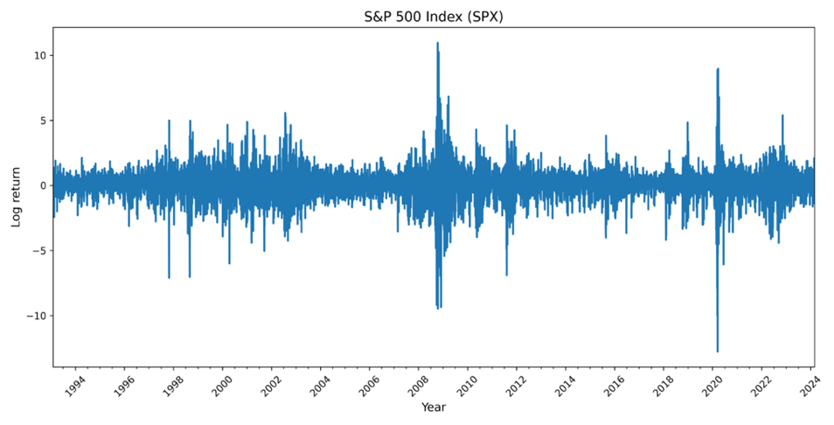
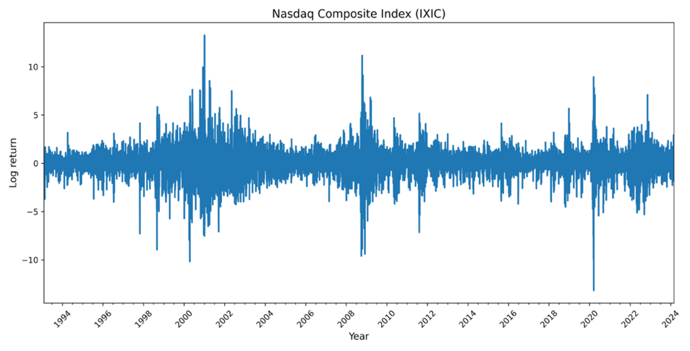
Figure 1. Logarithmic daily rate of return
Moreover, the UCT is derived from research by Rogers et al. (2024). The relevant data can be accessed for free via the Economic Policy Uncertainty website. Its construction method draws inspiration from the text analysis framework proposed by Baker et al. (2016) for the Economic Policy Uncertainty Index (EPU). Still, it has been substantially expanded in terms of variable extraction and theme identification.
Specifically, the UCT index measures the proportion of relevant texts in all reports by systematically tracking reports on U.S.-China tensions in mainstream U.S. media, focusing particularly on articles that simultaneously contain (i) references to the U.S. (the U.S. or Washington) and China (China or Beijing), (ii) sensitive topics in bilateral relations, and (iii) keyword combinations reflecting tension (the proportion of articles in which the word “tension” appears within ten words before or after “china”, “Chinese”, or “Beijing”).
To enhance identification accuracy, the research team combined K-means clustering, guided latent document association (guided LDA), and Newsmap machine learning algorithms to extract potential related keywords from a large number of manually annotated sample texts, thereby constructing an index that can dynamically capture changes in U.S.-China tensions. Compared to traditional geopolitical risk indices or economic policy uncertainty indices, the UCT places greater emphasis on the conflictual and sensitive dimensions specific to bilateral relations, thereby offering higher resolution and timeliness in identifying structural geopolitical frictions and event-driven market reactions.
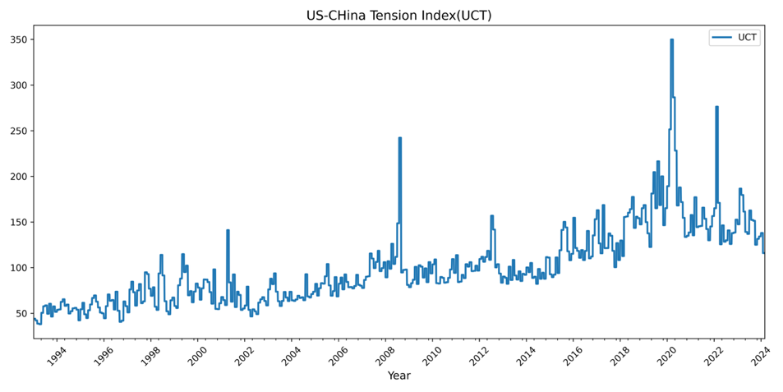
Figure 2. UCT Index
This is evident from Figure 2, which shows that the index rose significantly during several key events. For example, the bombing of the U.S. Embassy in Belgrade (1999), the mid-air collision between a U.S. military plane and a Chinese passenger plane over Hainan Island (2001), China becoming the largest foreign creditor of the United States and separatist unrest in Tibet and Xinjiang (2008), the United States issuing warnings to China over the South China Sea issue (2015), the United States imposing additional tariffs on China (2019), mutual accusations between China and the United States triggered by the outbreak of the COVID-19 pandemic (early 2020), and the outbreak of the Russia-Ukraine war (2022), among other events, the index experienced varying degrees of upward movement.
Additionally, Rogers et al. (2024) empirically found that an increase in the UCT index significantly suppressed the excess returns of U.S. companies with exposure to China, indicating that the index has been incorporated into investors' pricing considerations and possesses significant practical influence and explanatory power, thereby validating its substantive impact at the corporate level.
Considering data availability, the sample period of this study is set from February 1, 1993, to February 29, 2024. The daily returns of the SPX and IXIC indices are calculated as logarithmic returns and multiplied by 100. Similarly, the UCT index is taken as the first difference of the logarithmic value and amplified by 100 to measure its rate of change. The trend of UCT is shown in Figure 3.
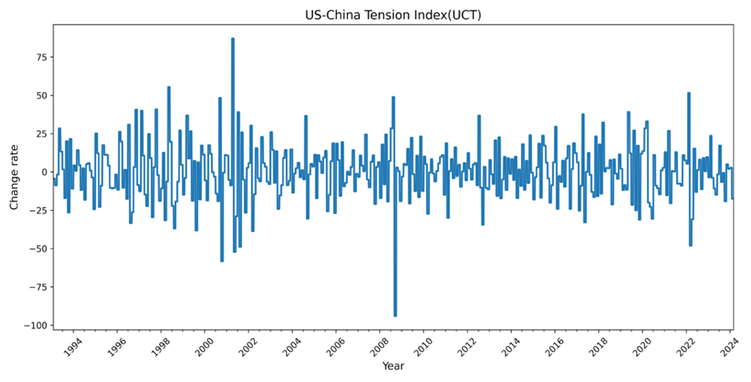
Figure 3. UCT rate of change
Table A1 presents the descriptive statistics of the daily returns of the two major U.S. stock markets and the UCT indicator. The results show that the mean daily returns of SPX and IXIC are 0.031 and 0.040, respectively, with standard deviations of 1.170 and 1.505, indicating that the Nasdaq, which is dominated by technology stocks, exhibits higher volatility. Among the realized volatility indicators, $RV_{SPX}$ is lower overall than, but has higher kurtosis. The UCT index exhibits significant volatility. All series passed the ADF test, confirming the stationarity of the data. Both return series exhibit left-skewed peak characteristics, and the Jarque-Bera test significantly rejects the assumption of normal distribution, consistent with the typical distribution characteristics of financial time series.

Appendix E: Tables
Table A1. Descriptive statistics
 | Mean | Max | Min | Std | Skew. | Kurt. | ADF | J-B
SPX | 0.031 | 10.964 | -12.766 | 1.170 | -0.405 | 13.598 | -16.290*** | 36839.582***
IXIC | 0.040 | 13.255 | -13.149 | 1.505 | -0.198 | 6.375 | -14.665*** | 13282.531***
$$RV_{SPX}$$ | 28.742 | 747.401 | 1.498 | 58.365 | 8.185 | 84.773 | -11.257*** | 112815.089***
$$RV_{IXIC}$$ | 47.529 | 710.166 | 2.907 | 72.990 | 4.533 | 28.070 | -4.526*** | 13173.903***
UCT | 0.259 | 87.142 | -93.970 | 18.699 | -0.027 | 2.767 | -9.778*** | 114.511***
Note: J-B stands for Jarque-Bera test for normal distribution, whose original hypothesis is that the series obeys normal distribution; ADF stands for Augmented Dickey-Fuller unit root test, whose null hypothesis is that the series contains a unit root, i.e., is non-stationary. ***,**,* denote the rejection of the original hypothesis at the 1%, 5% and 10% significance levels, respectively.

Table 1. In-sample estimation results for the model
 | SPX |  |  | IXIC
 | Model 1 | Model 2 | Model 3 | Model 1 | Model 2 | Model 3
$$μ$$ | 0.029***  (0.010) | 0.029***  (0.010) | 0.030***  (0.010) | 0.050***  (0.013) | 0.050***  (0.013) | 0.048***  (0.013)
$$α$$ | 2E-06  (0.006) | 2E-06  (0.006) | 2E-06  （0.006） | 0.002  (0.006) | 0.002  (0.006) | 0.001  (0.008)
$$β$$ | 0.846***  (0.008) | 0.846***  (0.008) | 0.837***  (0.009) | 0.841***  (0.010) | 0.842***  (0.010) | 0.831***  (0.012)
$$γ$$ | 0.224***  (0.012) | 0.224***  (0.012) | 0.223***  (0.013) | 0.198***  (0.012) | 0.198***  (0.012) | 0.206***  (0.014)
$$m$$ | -0.334***  (0.074) | -0.338***  (0.075) | -1.364***  (0.138) | -0.168**  (0.061) | -0.165**  (0.063) | -1.430***  (0.128)
$$θ_{RV}$$ | 0.017***  (0.001) | 0.014***  (0.001) | 0.011***  (0.001) | 0.013***  (0.001) | 0.013***  (0.001) | 0.008***  (0.001)
$$θ_{UCT}$$ |  | 0.013  (0.030) |  |  | -0.006  (0.013)
$$θ_{UCT^{+}}$$ |  |  | 0.003**  (0.002) |  |  | 0.005***  (0.002)
$$θ_{UCT^{-}}$$ |  |  | -0.004**  (0.001) |  |  | -0.005***  (0.001)
$$w_{2,RV}$$ | 6.167***  (0.775) | 6.119***  (0.808) | 7.500***  (0.156) | 5.837***  (0.664) | 5.831***  (0.709) | 1.000***  (0.223)
$$w_{2,UCT}$$ |  | 1.000  (0.342) |  |  | 10.074  (23.296)
$$w_{2,{UCT}^{+}}$$ |  |  | 1.000***  (0.333) |  |  | 1.000***  (0.223)
$$w_{2,{UCT}^{-}}$$ |  |  | 1.316***  (0.390) |  |  | 1.146***  (0.256)
$$LLH$$ | -9696.886 | -9696.826 | -9677.922 | -11487.658 | -11487.113 | -11454.887
$$BIC$$ | 19455.815 | 19473.420 | 19453.339 | 23037.358 | 23053.994 | 23007.269
Note: This table reports the parameter estimates of all the factor models. LLH is the log-likelihood function and BIC indicates the Bayesian information criterion. The numbers in parentheses are the standard errors. ∗∗∗, ∗∗, and ∗ denote respectively the significance levels at 1%, 5%, and 10%.

Table 2. MCS test results
1000 days | $$MSE$$ |  | $$MAE$$ |  | $$R^{2}LOG$$
 | $$T_{R}$$ | $$T_{max}$$ | $$T_{R}$$ | $$T_{max}$$ | $$T_{R}$$ | $$T_{max}$$
SPX
Model 1 | 0.312 | 0.225 | 0.253 | 0.239 | 0.121 | 0.363
Model 2 | 0.312 | 0.265 | 0.294 | 0.294 | 0.695 | 0.695
Model 3 | 1.000 | 1.000 | 1.000 | 1.000 | 1.000 | 1.000
IXIC
Model 1 | 0.415 | 0.212 | 0.290 | 0.129 | 0.426 | 0.214
Model 2 | 0.415 | 0.225 | 0.290 | 0.126 | 0.426 | 0.295
Model 3 | 1.000 | 1.000 | 1.000 | 1.000 | 1.000 | 1.000
Note: The numbers in the table are p-values. Numbers greater than 0.10 are in bold and underlined, indicating that the corresponding model performs significantly better in the model set. The time horizon is 1000 days.

Table 3. MCS test results
500 days | $$MSE$$ |  | $$MAE$$ |  | $$R^{2}LOG$$
 | $$T_{R}$$ | $$T_{max}$$ | $$T_{R}$$ | $$T_{max}$$ | $$T_{R}$$ | $$T_{max}$$
SPX
Model 1 | 0.486 | 0.240 | 0.055 | 0.027 | 0.000 | 0.000
Model 2 | 0.654 | 0.654 | 0.055 | 0.051 | 0.001 | 0.001
Model 3 | 1.000 | 1.000 | 1.000 | 1.000 | 1.000 | 1.000
IXIC
Model 1 | 0.199 | 0.403 | 0.001 | 0.000 | 0.000 | 0.000
Model 2 | 0.895 | 0.865 | 0.001 | 0.000 | 0.000 | 0.000
Model 3 | 1.000 | 1.000 | 1.000 | 1.000 | 1.000 | 1.000
Note: The numbers in the table are p-values. Numbers greater than 0.10 are in bold and underlined, indicating that the corresponding model performs significantly better in the model set. The time horizon is 500 days.

References
Baker, S. R., Bloom, N., & Davis, S. J. (2016). Measuring Economic Policy Uncertainty*. The Quarterly Journal of Economics, 131(4), 1593-1636. https://doi.org/10.1093/qje/qjw024
Bianconi, M., Esposito, F., & Sammon, M. (2021). Trade policy uncertainty and stock returns. Journal of International Money and Finance, 119, 102492. https://doi.org/https://doi.org/10.1016/j.jimonfin.2021.102492
Bouras, C., Christina, C., Rangan, G., & and Suleman, T. (2019). Geopolitical Risks, Returns, and Volatility in Emerging Stock Markets: Evidence from a Panel GARCH Model. Emerging Markets Finance and Trade, 55(8), 1841-1856. https://doi.org/10.1080/1540496X.2018.1507906
Caldara, D., & Iacoviello, M. (2022). Measuring Geopolitical Risk. American Economic Review, 112(4), 1194-1225. https://doi.org/10.1257/aer.20191823
Chiang, T. C. (2022). The effects of economic uncertainty, geopolitical risk and pandemic upheaval on gold prices. Resources Policy, 76, 102546. https://doi.org/https://doi.org/10.1016/j.resourpol.2021.102546
Conrad, C., & Kleen, O. (2020). Two are better than one: Volatility forecasting using multiplicative component GARCH-MIDAS models. Journal of Applied Econometrics, 35(1), 19-45. https://doi.org/https://doi.org/10.1002/jae.2742
Engle, R. F., Ghysels, E., & Sohn, B. (2013). STOCK MARKET VOLATILITY AND MACROECONOMIC FUNDAMENTALS. The Review of Economics and Statistics, 95(3), 776-797. http://www.jstor.org/stable/43554794
Feder-Sempach, E., Szczepocki, P., & Bogołębska, J. (2024). Global uncertainty and potential shelters: gold, bitcoin, and currencies as weak and strong safe havens for main world stock markets. Financial Innovation, 10(1), 67. https://doi.org/10.1186/s40854-023-00589-w
Glaser, C. L. (2015). A U.S.-China Grand Bargain? The Hard Choice between Military Competition and Accommodation. International Security, 39(4), 49-90. http://www.jstor.org/stable/24480607
Hao, X., Ma, Y., & Pan, D. (2024). Geopolitical risk and the predictability of spillovers between exchange, commodity and stock markets. Journal of Multinational Financial Management, 73, 100843. https://doi.org/https://doi.org/10.1016/j.mulfin.2024.100843
He, Z. (2023). Geopolitical risks and investor sentiment: Causality and TVP-VAR analysis. The North American Journal of Economics and Finance, 67, 101947. https://doi.org/https://doi.org/10.1016/j.najef.2023.101947
Li, S., Chen, H., & Chen, G. (2025). The US-China tension and fossil fuel energy price volatility relationship. Finance Research Letters, 74, 106707. https://doi.org/https://doi.org/10.1016/j.frl.2024.106707
Lu, C., Yu, F., Li, J., & Li, S. (2024). Research on safe-haven currencies under global uncertainty —A new perception based on the East Asian market. Global Finance Journal, 62, 101013. https://doi.org/https://doi.org/10.1016/j.gfj.2024.101013
Rogers, J. H., Sun, B., & Sun, T. (2024). US-China tension. Available at SSRN 4815838.
Salachas, E., Kouretas, G. P., Laopodis, N. T., & Vlamis, P. (2024). Stock market spillovers of global risks and hedging opportunities. European Journal of Political Economy, 83, 102533. https://doi.org/https://doi.org/10.1016/j.ejpoleco.2024.102533
Triki, M. B., & Ben Maatoug, A. (2021). The GOLD market as a safe haven against the stock market uncertainty: Evidence from geopolitical risk. Resources Policy, 70, 101872. https://doi.org/https://doi.org/10.1016/j.resourpol.2020.101872
Wang, K.-M., & Lee, Y.-M. (2022). Is gold a safe haven for exchange rate risks? An empirical study of major currency countries. Journal of Multinational Financial Management, 63, 100705. https://doi.org/https://doi.org/10.1016/j.mulfin.2021.100705
Yilmazkuday, H. (2025). U.S. tariffs and stock prices. Finance Research Letters, 83, 107708. https://doi.org/https://doi.org/10.1016/j.frl.2025.107708
Zaremba, A., Cakici, N., Demir, E., & Long, H. (2022). When bad news is good news: Geopolitical risk and the cross-section of emerging market stock returns. Journal of Financial Stability, 58, 100964. https://doi.org/https://doi.org/10.1016/j.jfs.2021.100964
Zhang, K. H. (2024). Geoeconomics of US-China tech rivalry and industrial policy. Asia and the Global Economy, 4(2), 100098. https://doi.org/https://doi.org/10.1016/j.aglobe.2024.100098
Zhang, Y., He, J., He, M., & Li, S. (2023). Geopolitical risk and stock market volatility: A global perspective. Finance Research Letters, 53, 103620. https://doi.org/https://doi.org/10.1016/j.frl.2022.103620
Zheng, J., Wen, B., Jiang, Y., Wang, X., & Shen, Y. (2023). Risk spillovers across geopolitical risk and global financial markets. Energy Economics, 127, 107051. https://doi.org/https://doi.org/10.1016/j.eneco.2023.107051

Investing.com platform: https://www.investing.com/indices/us-spx-500-historical-data (SPX); https://www.investing.com/indices/nasdaq-composite-historical-data (IXIC)
Economic Policy Uncertainty Index website: https://policyuncertainty.com/US_China_Tension.html

